Practical no. 2: Basic Queries

1] Insert the document

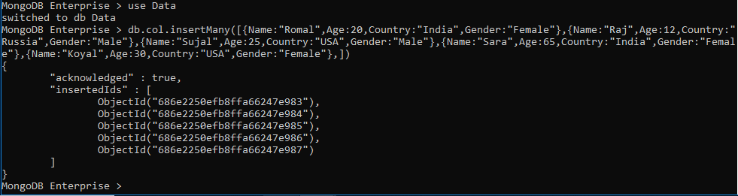

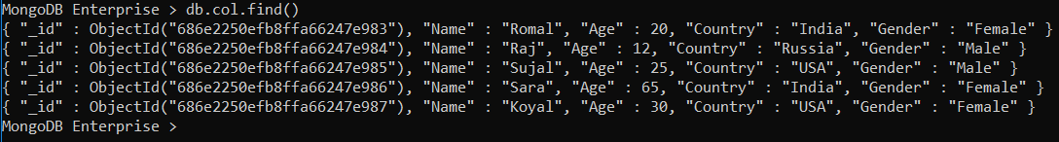

2] Update the country to UK for all female users.

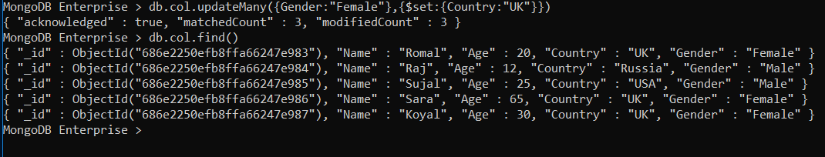

3] Add the new field company to all the document.

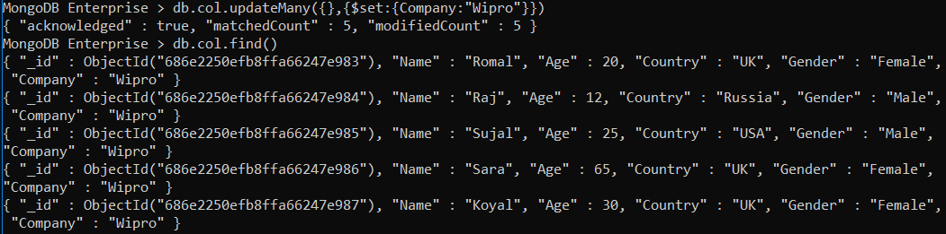

4] Delete all the document where Gender=’M’

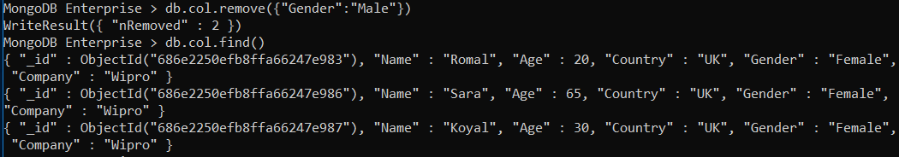

5] Find out a count of female users who stay in either India or USA.



6] Display the first name and age of all female employees.

